## **CHAPTER 1 :- OPAMP**

## **What is an Operational Amplifier?**

 An [operational amplifier](https://www.monolithicpower.com/en/products/analog/precision-analog/operational-amplifiers.html) (**OP AMP** ) is an analog circuit block that takes a differential voltage input and produces a single-ended voltage output.

Op amps usually have three terminals: two high-impedance inputs and a low-impedance output port. The inverting input is denoted with a minus (-) sign, and the non-inverting input uses a positive (+) sign. Operational amplifiers work to amplify the voltage differential between the inputs, which is useful for a variety of analog functions including signal chain, power, and control applications.

## **Operational Amplifier Classification**

 There are four ways to classify [operational amplifiers](https://www.monolithicpower.com/en/products/analog/precision-analog/operational-amplifiers.html):

* Voltage amplifiers take voltage in and produce a voltage at the output.
* Current amplifiers receive a current input and produce a current output.
* Transconductance amplifiers convert a voltage input to a current output.
* Trans resistance amplifiers convert a current input and produces a voltage output.

Because most op amps are used for voltage amplification, this article will focus on voltage amplifiers.

## **Operational Amplifiers: Key Characteristics and Parameters**

 There are many different important characteristics and parameters related to op amps **(see Figure 1)**. These characteristics are described in greater detail below.

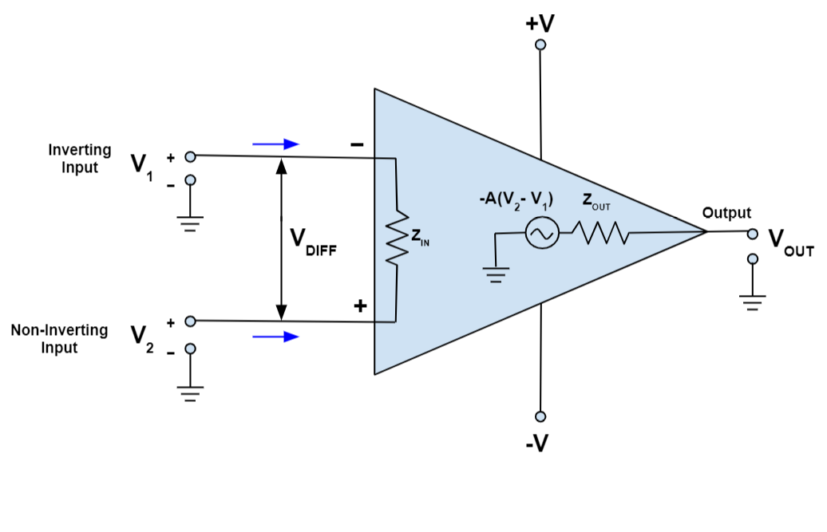

Figure 1: Operational Amplifier Schematic

### **Open-loop gain**

Open-loop gain: The open-loop gain (“A” in **Figure 1**) of an [operational amplifier](https://www.monolithicpower.com/en/products/analog/precision-analog/operational-amplifiers.html) is the measure of the gain achieved when there is no feedback implemented in the circuit. This means the feedback path, or loop, is open. An open-loop gain often must be exceedingly large (10,000+) to be useful in itself, except with voltage comparators.

 Voltage comparators compare the input terminal voltages. Even with small voltage differentials, voltage comparators can drive the output to either the positive or negative rails. High open-loop gains are beneficial in closed-loop configurations, as they enable stable circuit behaviours across temperature, process, and signal variations.

### **Input Impedance**

Another important characteristic of op amps is that they generally have high input impedance (“ZIN” in **Figure 1**). Input impedance is measured between the negative and positive input terminals, and its ideal value is infinity, which minimizes loading of the source. (In reality, there is a small current leakage.) Arranging the circuitry around an operational amplifier may significantly alter the effective input impedance for the source, so external components and feedback loops must be carefully configured. It is important to note that input impedance is not solely determined by the input DC resistance. Input capacitance can also influence circuit behaviour, so that must be taken into consideration as well.

### **Output impedance**

An operational amplifier ideally has zero output impedance (“ZOUT” in **Figure 1**). However, the output impedance typically has a small value, which determines the amount of current it can drive, and how well it can operate as a voltage buffer.

### **Frequency response and bandwidth (BW)**

An ideal op amp would have an infinite bandwidth (BW), and would be able to maintain a high gain regardless of signal frequency. However, all operational amplifiers have a finite bandwidth, generally called the “-3dB point,” where the gain begins to roll as frequency increases. The gain of the amplifier then decreases at a rate of -20dB/decade while the frequency increases. Op amps with a higher BW have improved performance because they maintain higher gains at higher frequencies; however, this higher gain results in larger power consumption or increased cost.

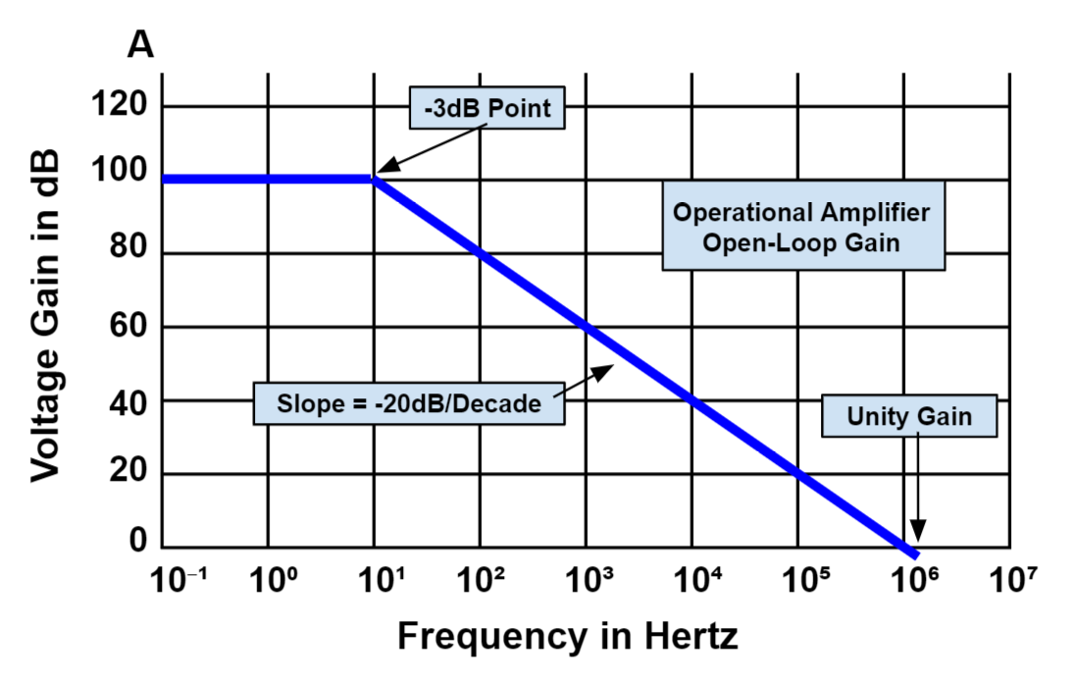

Figure 2: Operational Amplifier Open-Loop Frequency Response Curve

### **Gain bandwidth product (GBP)**

As the name suggests, GBP is a product of the amplifier’s gain and bandwidth. GBP is a constant value across the curve, and can be calculated with **Equation (1):**

GBP=GainxBandwidth=AxBW𝐺𝐵𝑃=𝐺𝑎𝑖𝑛𝑥𝐵𝑎𝑛𝑑𝑤𝑖𝑑𝑡ℎ=𝐴𝑥𝐵𝑊

GBP is measured at the frequency point at which the operational amplifier’s gain reaches unity. This is useful because it allows the user to calculate the device’s open-loop gain at different frequencies. An operational amplifier’s GBP is generally a measure of its usefulness and performance, as op amps with a higher GBP can be used to achieve better performance at higher frequencies.

These are the major parameters to consider when selecting an operational amplifier in your design, but there are many other considerations that may influence your design, depending on the application and performance needs. Other common parameters include input offset voltage, noise, quiescent current, and supply voltages.

## **Negative Feedback and Closed-Loop Gain**

 In an operational amplifier, negative feedback is implemented by feeding a portion of the output signal through an external feedback resistor and back to the inverting input **(see Figure 3)**.

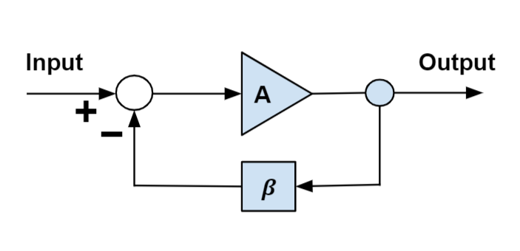

Figure 3: Negative Feedback with Inverting Operational Amplifier

Negative feedback is used to stabilize the gain. By using negative feedback, the closed-loop gain can be determined via external feedback components that can have higher accuracy compared to the operational amplifier’s internal components. This is because the internal op amp components may vary substantially due to process shifts, temperature changes, voltage changes, and other factors. The closed-loop gain can be calculated with **Equation (2)**:

VOUTVIN=1f𝑉𝑂𝑈𝑇𝑉𝐼𝑁=1𝑓

## **Operational Amplifiers: Advantages and Limitations**

 There are many advantages to using an operational amplifier. Operational amplifiers often come in the form of an IC, and are widely available, with countless selectable performance levels to meet every application’s needs. Op amps have a broad range of usages, and as such are a key building block in many analog applications — including filter designs, voltage buffers, comparator circuits, and many others. In addition, most companies provide simulation support, such as PSPICE models, for designers to validate their operational amplifier designs before building real designs.

The limitations to using operational amplifiers include the fact they are analog circuits, and require a designer that understands analog fundamentals such as loading, frequency response, and stability. It is not uncommon to design a seemingly simple op amp circuit, only to turn it on and find that it is oscillating. Due to some of the key parameters discussed earlier, the designer must understand how those parameters play into their design, which typically means the designer must have a moderate to high level of analog design experience.

## **Operational Amplifier Configuration Topologies**

 There are several different op amp circuits, each differing in function. The most common topologies are described below.

### **Voltage follower**

The most basic operational amplifier circuit is a voltage follower **(see Figure 4)**. This circuit does not generally require external components, and provides high input impedance and low output impedance, which makes it a useful buffer. Because the voltage input and output are equal, changes to the input produce equivalent changes to the output voltage.

VOUT=VIN𝑉𝑂𝑈𝑇=𝑉𝐼𝑁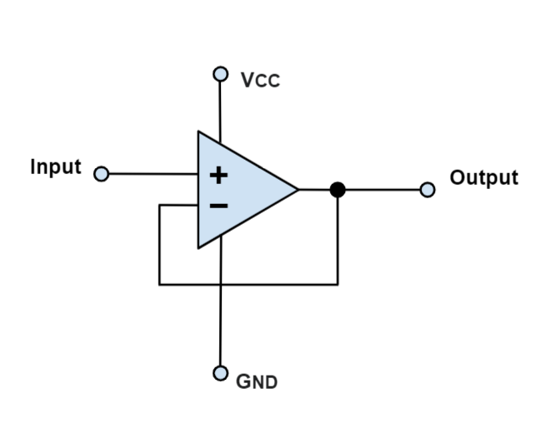

Figure 4: Voltage Follower

The most common op amp used in electronic devices are voltage amplifiers, which increase the output voltage magnitude. Inverting and non-inverting configurations are the two most common amplifier configurations. Both of these topologies are closed-loop (meaning that there is feedback from the output back to the input terminals), and thus voltage gain is set by a ratio of the two resistors.

### **Inverting operational amplifier**

In inverting operational amplifiers, the op amp forces the negative terminal to equal the positive terminal, which is commonly ground. Therefore, the input current is determined by the VIN / R1 ratio **(see Figure 5)**.

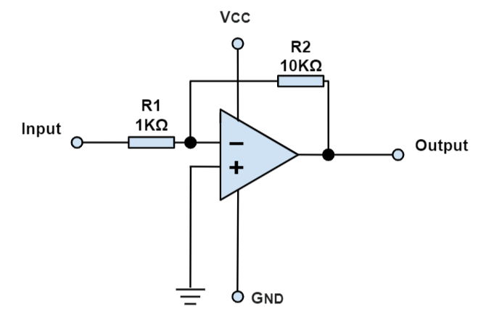

Figure 5: Inverting Operational Amplifier

In this configuration, the same current flows through R2 to the output. Ideally, current does not flow into the operational amplifier’s negative terminal due to its high ZIN. The current flowing from the negative terminal through R2 creates an inverted voltage polarity with respect to VIN. This is why these op amps are labeled with an inverting configuration. Note that the op amp’s output can only swing between its positive and negative supplies, so creating a negative output voltage requires an op amp with a negative supply rail. VOUT can be calculated with **Equation (3)**:

VOUT=−(R2R1)xVIN𝑉𝑂𝑈𝑇=−(𝑅2𝑅1)𝑥𝑉𝐼𝑁

### **Non-inverting operational amplifier**

In a non-inverting amplifier circuit, the input signal from the source is connected to the non-inverting (+) terminal **(see Figure 6)**.

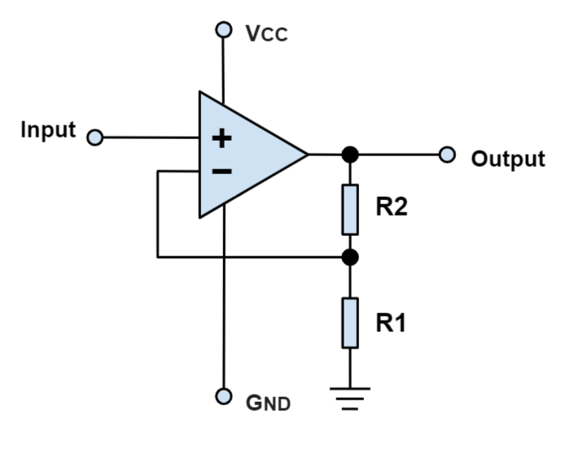

Figure 6: Non-Inverting Operational Amplifier

The operational amplifier forces the inverting (-) terminal voltage to equal the input voltage, which creates a current flow through the feedback resistors. The output voltage is always in phase with the input voltage, which is why this topology is known as non-inverting. Note that with a non-inverting amplifier, the voltage gain is always greater than 1, which is not always the case with the inverting configurations. VOUT can be calculated with **Equation (4)**:

VOUT=(1+R2R1)×VIN𝑉𝑂𝑈𝑇=(1+𝑅2𝑅1)×𝑉𝐼𝑁

### **Voltage comparator**

An operational amplifier voltage comparator compares voltage inputs, and drives the output to the supply rail of whichever input is higher. This configuration is considered open-loop operation because there is no feedback. Voltage comparators have the benefit of operating much faster than the closed-loop topologies discussed above **(see Figure 7)**.

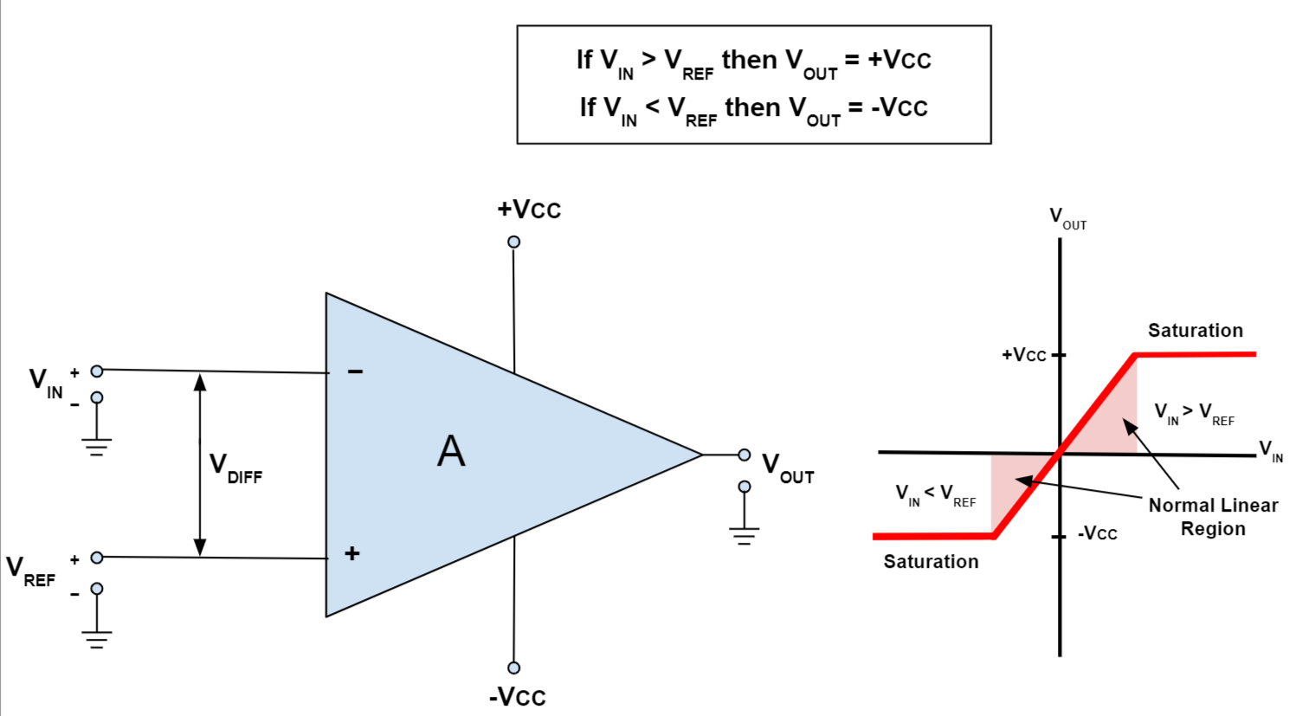

Figure 7: Voltage Comparator

## **How to Choose an Operational Amplifier for Your Application**

 The section below discusses certain considerations when selecting the proper operational amplifier for your application.

 Firstly, [choose an op amp that can support your expected operating voltage range](https://www.monolithicpower.com/en/products/precision-analog/operational-amplifiers.html). This information can be obtained by looking at the amplifier’s power supply voltages. The supply voltages will likely either be VDD (+) and ground (single supply), or the amplifier may be able to support both a positive and negative supply. A negative supply is useful if the output needs to support negative voltages.

 Secondly, consider the amplifier’s GBP. If your application needs to support higher frequencies, or requires a higher performance and reduced distortion, consider op amps with higher GBPs.

 One should also consider the power consumption, as certain applications may require low-power operation. The recommended power requirements can typically be found in the part’s datasheet, and are usually listed as supply current and power consumption. Power consumption can also be estimated from the product of the supply current and supply voltage. Generally, op amps with lower supply currents have lower GBP, and correspond with lower circuit performance.

 For applications that require higher accuracy, the designer should pay special attention to the amplifier’s input offset voltage, as this voltage leads to an offset in the amplifier's output voltage.

**CHAPTER 2 :- TWO STAGE OPAMP**

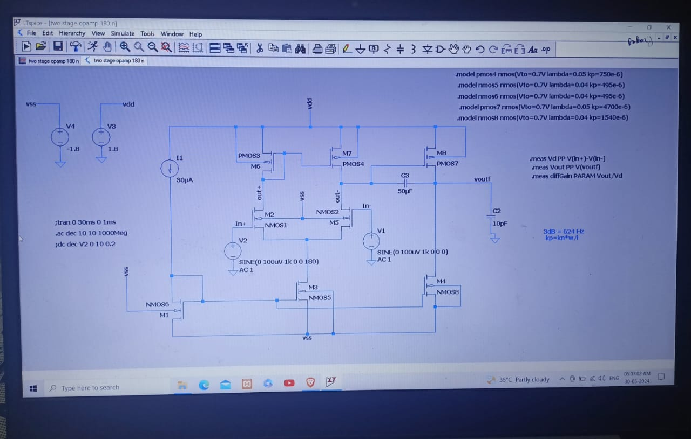

### Design Description of a Two-Stage OPAMP

#### **1. Overview of the Architecture**

The two-stage OPAMP consists of two main amplification stages:

* **First Stage:** Differential input stage
* **Second Stage:** Gain stage (also called the output stage)

This configuration allows for high voltage gain while maintaining good stability and bandwidth.

#### **2. First Stage: Differential Input Stage**

The differential input stage is the initial amplification stage of the OPAMP. Its main components include:

* **Differential Pair Transistors (M1 and M2):** These transistors receive the input signals (V_in+ and V_in-). They amplify the differential input voltage.
* **Current Mirror Load (M3 and M4):** This load provides a high impedance to maximize the gain of the differential pair. The current mirror also helps in biasing the transistors and ensuring that the differential current is mirrored accurately.
* **Tail Current Source (I_tail):** This current source provides a constant bias current to the differential pair, stabilizing the operation of the input stage.

**Operation:**

* The differential pair (M1 and M2) converts the input voltage difference into a current difference.
* The current mirror (M3 and M4) converts this differential current back into a voltage, providing the first stage's output.

#### 3. **Second Stage: Gain Stage**

The second stage is designed to further amplify the signal coming from the first stage. Its main components include:

* **Common-Source Amplifier (M5):** This transistor acts as the main amplification element in the second stage.
* **Load (R_load or M6):** The load can be a resistor or an active load (another transistor configured to act as a high impedance load), which maximizes the gain of the second stage.
* **Compensation Capacitor (Cc):** This capacitor is used to ensure the stability of the opamp by creating a dominant pole and enhancing phase margin.

**Operation:**

* The signal from the first stage is fed into the gate of M5, which amplifies it.
* The amplified signal is then taken from the drain of M5, which is loaded by either a resistor or an active load.

#### **4. Compensation and Stability**

Stability is a crucial aspect of OPAMP design, and compensation techniques are used to ensure the OPAMP remains stable across its operating frequency range.

* **Miller Compensation (Cc):** A compensation capacitor (Cc) is connected between the output of the first stage and the output of the second stage. This technique is known as Miller compensation and helps create a dominant pole in the frequency response, improving the phase margin and ensuring stability.
* **Zero Compensation:** Sometimes, a series resistor is added with the compensation capacitor to introduce a zero in the frequency response, further improving stability.

#### **5. Biasing Circuits**

Proper biasing is essential for the reliable operation of the opamp. The biasing circuit typically includes:

* **Current Mirrors:** Used to establish constant current sources for different stages.
* **Bias Voltages:** Generated using reference circuits to ensure stable operating points for the transistors.

### Detailed Design Considerations

1. **Gain Calculation:**
   * The gain of the first stage (A1) is determined by the transconductance (gm) of the differential pair transistors and the output impedance of the current mirror load.
   * The gain of the second stage (A2) is determined by the transconductance of M5 and the impedance of the load.
2. **Frequency Response:**
   * The dominant pole is introduced by the Miller compensation capacitor (C_c), which typically lowers the bandwidth but increases stability.
   * The second pole is usually at a higher frequency, determined by

the internal node capacitances and the load impedance of the second stage. Proper compensation ensures that the opamp maintains a stable phase margin, preventing oscillations.

1. **Slew Rate:**
   * The slew rate is influenced by the current driving capability of the differential pair and the compensation capacitor. Higher tail currents in the differential pair and appropriate sizing of the compensation capacitor can improve the slew rate.
2. **Offset Voltage:**
   * Input offset voltage arises due to mismatches in the differential pair transistors. Careful layout design and matching techniques are employed to minimize these mismatches and reduce the offset voltage.
3. **Noise Performance:**
   * Noise in the opamp is contributed by various sources including thermal noise from resistors and flicker noise from transistors. The design aims to minimize noise by optimizing the transistor sizes and bias currents.

### Example Design

Let's consider an example of a two-stage opamp design using 180nm technology.

#### First Stage: Differential Input Stage

* **Transistors:** M1 and M2 (NMOS differential pair)
* **Current Mirror Load:** M3 and M4 (PMOS current mirror)
* **Tail Current Source:** M5 (NMOS) with a current source providing Itail=100μAI_{tail} = 100\mu AItail​=100μA

**Design Calculations:**

* Differential pair transconductance: gm1=ItailVov1g_m1 = \frac{I_{tail}}{V_{ov1}}gm​1=Vov1​Itail​​ where Vov1V_{ov1}Vov1​ is the overdrive voltage of M1 and M2.
* Current mirror transistors M3 and M4 are sized to ensure accurate current mirroring.

#### **Second Stage: Gain Stage**

* **Transistor:** M6 (NMOS common-source amplifier)
* **Load:** M7 (PMOS active load)
* **Compensation Capacitor:** Cc = 1pF (Miller compensation)

**Design Calculations:**

* Transconductance of M6: gm6=ID6Vov6g_m6 = \frac{I_{D6}}{V_{ov6}}gm​6=Vov6​ID6​​
* Output impedance of the active load: ro7=1λID7r_o7 = \frac{1}{\lambda I_{D7}}ro​7=λID7​1​

#### **Compensation and Stability**

* **Miller Compensation:** The capacitor Cc = 1pF is connected between the output of the first stage and the output of the second stage to ensure a dominant pole at low frequency.
* **Phase Margin:** A series resistor Rc (typically in the range of 50-100 ohms) might be added with Cc to introduce a zero in the frequency response, improving the phase margin.

#### **Biasing Circuits**

* **Current Mirrors:** Designed using PMOS and NMOS transistors to generate the necessary bias currents for the differential pair and the gain stage.
* **Reference Voltage:** Generated using a bandgap reference circuit to ensure stable operation across temperature variations

and supply voltage changes.

### **CHAPTER 3 – 180 NM and 90NM Technology**

### **Detailed Description of 180nm Technology**

**Overview:**

180nm (0.18 micron) technology, developed in the late 1990s, represents a significant milestone in semiconductor fabrication. It allowed for increased transistor density, lower power consumption, and enhanced performance compared to previous nodes.

**Key Characteristics:**

* **Feature Size:** 180nm refers to the minimum gate length of the transistors.
* **Voltage Levels:** Typically operates at a core voltage of around 1.8V, with I/O voltages often at 3.3V or 2.5V.
* **Transistor Performance:** Offers moderate drive current capabilities with lower leakage currents compared to smaller nodes.
* **Gate Oxide Thickness:** Typically around 3-4nm, providing a balance between gate control and leakage current.
* **Interconnect:** Aluminium or copper interconnects with low-k dielectric materials to reduce capacitance and RC delays.
* **Applications:** Widely used in automotive, industrial, and consumer electronics where moderate performance and low cost are crucial.

**Advantages:**

* **Maturity:** Well-established process with robust manufacturing techniques and extensive design libraries.
* **Cost:** Lower manufacturing costs due to mature fabrication processes.
* **Power Consumption:** Moderate power consumption suitable for many applications without stringent power constraints.
* **Design Complexity:** Less complex design rules compared to more advanced nodes, making it easier to achieve high yield.

**Challenges:**

* **Performance:** Lower speed and higher power consumption compared to newer nodes.
* **Integration Density:** Lower transistor density, leading to larger chip sizes for complex designs.
* **Leakage Current:** Higher than in newer nodes, but manageable with proper design techniques.

### **Detailed Description of 90nm Technology**

**Overview:** 90nm (0.09 micron) technology, introduced in the early 2000s, marked a significant advancement in semiconductor fabrication, enabling higher performance, reduced power consumption, and increased transistor density.

**Key Characteristics:**

* **Feature Size:** 90nm refers to the minimum gate length of the transistors, allowing for higher integration density.
* **Voltage Levels:** Typically operates at a core voltage of around 1.2V to 1.5V, with I/O voltages often at 2.5V or 1.8V.
* **Transistor Performance:** Enhanced drive current capabilities with lower threshold voltages and improved switching speeds.
* **Gate Oxide Thickness:** Typically around 1.2-1.5nm, providing better gate control and reduced leakage currents.
* **Interconnect:** Copper interconnects with advanced low-k dielectric materials to further reduce capacitance and RC delays.
* **Applications:** Used in high-performance computing, mobile devices, and advanced consumer electronics requiring higher speed and lower power consumption.

**Advantages:**

* **Performance:** Higher switching speeds and better drive current capabilities compared to 180nm technology.
* **Power Consumption:** Lower core voltages and reduced leakage currents contribute to overall lower power consumption.
* **Integration Density:** Higher transistor density allows for more complex designs and increased functionality on a single chip.
* **Advanced Features:** Support for advanced low-power and high-speed design techniques such as multi-threshold CMOS (MTCMOS) and adaptive body biasing.

**Challenges:**

* **Design Complexity:** More stringent design rules and variability issues due to smaller geometries.
* **Manufacturing Costs:** Higher costs associated with advanced fabrication techniques and materials.
* **Leakage Current:** Although improved, managing leakage current remains a challenge, especially for low-power applications.
* **Short-Channel Effects:** Increased susceptibility to short-channel effects, requiring advanced design techniques to mitigate.

### **Differences Between 180nm and 90nm Technologies**

| **Feature** | **180nm Technology** | **90nm Technology** |  |
| --- | --- | --- | --- |
| **Feature Size** | 180nm | 90nm |  |
| **Core Voltage** | Typically, 1.8V | Typically, 1.2V to 1.5V |  |
| **Gate Oxide Thickness** | 3-4nm | 1.2-1.5nm |  |
| **Interconnect** | Aluminium or Copper with low-k dielectric | Copper with advanced low-k dielectric |  |
| **Transistor Density** | Lower integration density | Higher integration density |  |
| **Power Consumption** | Moderate power consumption | Lower power consumption |  |
| **Switching Speed** | Moderate | Higher |  |
| **Design Rules** | Less stringent, easier to achieve high yield | More stringent, higher design complexity |  |
| **Applications** | Automotive, industrial, consumer electronics | High-performance computing, mobile devices, advanced consumer electronics |  |
| **Leakage Current** | Higher leakage current compared to 90nm | Lower leakage current, but still a concern |  |
| **Manufacturing Costs** | Lower due to mature processes | Higher due to advanced fabrication techniques |  |
| **Short-Channel Effects** | Less pronounced | More pronounced, requiring advanced design techniques |  |

### **CHAPTER 4 LT spice Tool**

### **Detailed Theory on LTspice Tool**

#### **1. Overview**

**LTspice** is a high-performance SPICE (Simulation Program with Integrated Circuit Emphasis) simulator, schematic capture, and waveform viewer developed by Analog Devices (originally by Linear Technology). It is used to simulate analog and digital circuits, allowing engineers and designers to test their circuits before building physical prototypes.

#### **2. Features**

**Key Features of LTspice:**

* **Schematic Capture:** Allows users to draw and modify circuit schematics using a graphical interface.
* **Simulation Engine:** Runs simulations based on SPICE (Simulation Program with Integrated Circuit Emphasis) models.
* **Waveform Viewer:** Displays simulation results as waveforms for analysis.
* **Component Library:** Includes a vast library of components like resistors, capacitors, inductors, transistors, diodes, and integrated circuits.
* **Macro Models:** Provides detailed models of Analog Devices and Linear Technology components.
* **Parameter Sweeping:** Supports parameter sweeping for analyzing circuit behaviour over a range of values.
* **Monte Carlo Analysis:** Allows for statistical analysis to evaluate circuit performance variability.

#### **3. Using LTspice**

**Steps to Use LTspice:**

**Step 1: Install LTspice**

* Download and install LTspice from the Analog Devices website.

**Step 2: Create a New Schematic**

* Open LTspice and create a new schematic by selecting "File" > "New Schematic".

**Step 3: Place Components**

* Use the component symbol toolbar or press F2 to open the component library. Select and place components on the schematic.
* Example components include resistors (R), capacitors (C), inductors (L), voltage sources (V), and operational amplifiers.

**Step 4: Connect Components**

* Use the wiring tool to connect components by clicking on the component terminals and dragging wires to the desired connection points.

**Step 5: Set Component Values**

* Right-click on each component to set its value (e.g., resistance for resistors, capacitance for capacitors).

**Step 6: Add Simulation Command**

* Place a simulation command by pressing "Simulate" > "Edit Simulation Cmd". Choose the type of analysis (e.g., transient, AC analysis, DC sweep) and specify the parameters.

**Step 7: Run Simulation**

* Click the "Run" button or press the "Run" icon in the toolbar to start the simulation.

**Step 8: View Results**

* The waveform viewer will open automatically. Select the nodes or components you want to analyze by clicking on them in the schematic.

#### **4. Types of Analysis**

**Common Types of Analysis in LTspice:**

**Transient Analysis:**

* Used to analyze the time-domain response of circuits.
* Command: .tran tstop [tstart [tstep [tmaxstep]]]
  + tstop: Stop time for the simulation.
  + tstart: (Optional) Start time for the simulation.
  + tstep: (Optional) Time step for the simulation.
  + tmaxstep: (Optional) Maximum time step.

**AC Analysis:**

* Used to analyze the frequency-domain response of circuits.
* Command: .ac oct/dec/lin n fstart fstop
  + oct/dec/lin: Specifies the type of sweep (octave, decade, or linear).
  + n: Number of points per octave/decade/linear sweep.
  + fstart: Start frequency.
  + fstop: Stop frequency.

**DC Sweep:**

* Used to analyze the DC response by sweeping a parameter (e.g., voltage, current).
* Command: .dc srcname start stop step
  + srcname: Name of the source to sweep.
  + start: Start value of the sweep.
  + stop: Stop value of the sweep.
  + step: Incremental step value.

**Noise Analysis:**

* Used to analyze the noise performance of circuits.
* Command: .noise V(out) Vin [octave/decade/lin] npoints fstart fstop
  + V(out): Output voltage node.
  + Vin: Input source name.
  + octave/decade/lin: Type of sweep.
  + npoints: Number of points per octave/decade/linear sweep.
  + fstart: Start frequency.
  + fstop: Stop frequency.

#### **5. Advanced Features**

**Parameter Sweeping:**

* Allows varying a component value to see its effect on circuit behavior.
* Use .step command to perform parameter sweep.
* Example: .step param R1 1k 10k 1k (sweeps resistor R1 from 1kΩ to 10kΩ in 1kΩ steps).

**Monte Carlo Analysis:**

* Evaluates the impact of component tolerances on circuit performance.
* Use .param and .func commands to define parameter variations.
* Example: .param R1 = {1k*(1+gauss(0,0.1))} (defines R1 with a Gaussian variation of 10%).

**Temperature Sweep:**

* Analyzes circuit behaviour over a range of temperatures.
* Use .temp command to specify temperature range.
* Example: .temp -40 25 85 (sweeps temperature from -40°C to 85°C).

#### **6. Tips for Effective Simulation**

* **Accuracy vs. Speed:** Adjust simulation accuracy settings to balance between accuracy and simulation speed. Use .options command to set parameters like reltol, abstol, and vntol.
* **Convergence:** Ensure proper circuit convergence by avoiding unrealistic component values and ensuring initial conditions are set appropriately.
* **Subcircuits and Hierarchical Design:** Use subcircuits to simplify complex designs and enhance readability. Define subcircuits using .subckt and .ends commands.

**CHAPTER 5**

**THEORY OF AC , DC AND TRANSIENT ANALYSIS**

### **AC Analysis**

**Purpose:** AC analysis is used to determine the frequency response of a circuit. It provides information about the gain and phase shift of the circuit over a range of frequencies.

**Setup:**

1. **Circuit Preparation:**
   * Ensure your circuit has a small signal AC source (usually a voltage source) to inject the AC signal.
   * Place the AC source where you want to analyze the frequency response (e.g., input of an amplifier).
2. **Define AC Analysis Command:**
   * Go to Simulate > Edit Simulation Cmd.
   * Select the AC Analysis tab.
   * Choose the type of sweep: Decade, Octave, or Linear.
   * Specify the number of points per decade/octave or the total number of points for a linear sweep.
   * Set the start and stop frequencies for the analysis.

Example command: .ac dec 100 10 1Meg

* + This command performs a decade sweep with 100 points per decade from 10Hz to 1MHz.

1. **Run Simulation:**
   * Click on the Run button to start the simulation.
   * View the results in the waveform viewer by selecting the nodes or components you want to analyze.

**Interpreting Results:**

* **Bode Plot:** Shows the gain (in dB) and phase shift (in degrees) versus frequency.
* **Resonant Frequency:** Look for peaks or dips indicating resonant frequencies.
* **Bandwidth:** Determine the frequency range where the circuit operates effectively.

### **DC Analysis**

**Purpose:** DC analysis is used to determine the operating point (DC bias point) of the circuit and how the circuit responds to varying DC inputs.

**Setup:**

1. **Circuit Preparation:**
   * Ensure your circuit is properly biased with DC sources.
   * Place DC voltage or current sources where you want to sweep or analyze the DC behavior.
2. **Define DC Sweep Command:**
   * Go to Simulate > Edit Simulation Cmd.
   * Select the DC Sweep tab.
   * Choose the source to sweep (e.g., a voltage source).
   * Specify the start, stop, and step values for the sweep.

Example command: .dc V1 0 5 0.1

* + This command sweeps the voltage source V1 from 0V to 5V in 0.1V steps.

1. **Run Simulation:**
   * Click on the Run button to start the simulation.
   * View the results in the waveform viewer by selecting the nodes or components you want to analyze.

**Interpreting Results:**

* **IV Characteristics:** Plot current versus voltage to understand the behavior of diodes, transistors, etc.
* **Operating Point:** Determine the DC operating point (Q-point) of active devices like transistors.
* **Transfer Characteristics:** Plot the output versus input voltage to analyze the transfer function of amplifiers and other circuits.

### Transient Analysis

**Purpose:** Transient analysis is used to study the time-domain response of the circuit. It helps analyze how the circuit responds to time-varying inputs and to observe dynamic behaviors such as oscillations, rise times, and settling times.

**Setup:**

1. **Circuit Preparation:**
   * Include time-varying sources like pulse, sine, or piecewise linear (PWL) sources.
   * Ensure all initial conditions are set if necessary (e.g., initial voltages for capacitors).
2. **Define Transient Analysis Command:**
   * Go to Simulate > Edit Simulation Cmd.
   * Select the Transient tab.
   * Specify the stop time (Tstop) for the simulation. Optional parameters include start time (Tstart), time step (Tstep), and maximum step size (Tmaxstep).

Example command: .tran 1m

* + This command runs a transient simulation for 1 millisecond.

1. **Run Simulation:**
   * Click on the Run button to start the simulation.
   * View the results in the waveform viewer by selecting the nodes or components you want to analyze.

**Interpreting Results:**

* **Waveform Analysis:** Observe voltage and current waveforms over time.
* **Rise/Fall Time:** Measure the time it takes for signals to transition between low and high states.
* **Steady-State Behavior:** Analyze the steady-state response after initial transients have settled.
* **Oscillations:** Identify and study any oscillatory behavior in the circuit.

**CHAPTER 6**

**­­­ RESULTS-:**

* 1. **180 NM TECHNOLOGY**

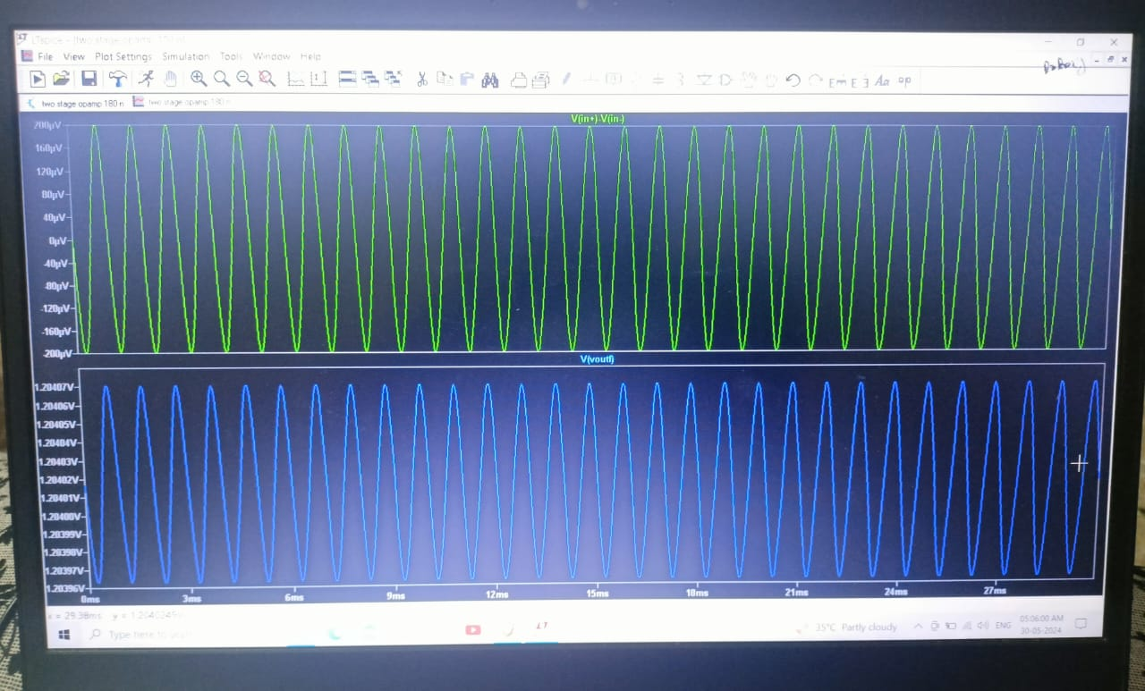

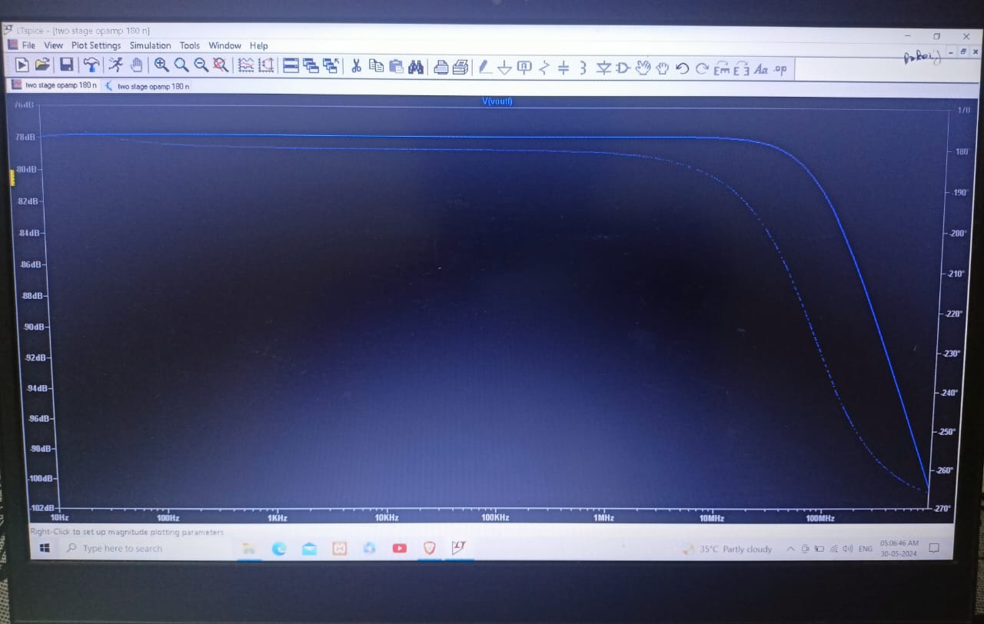



* 1. **90 NM TECHNOLOGY**

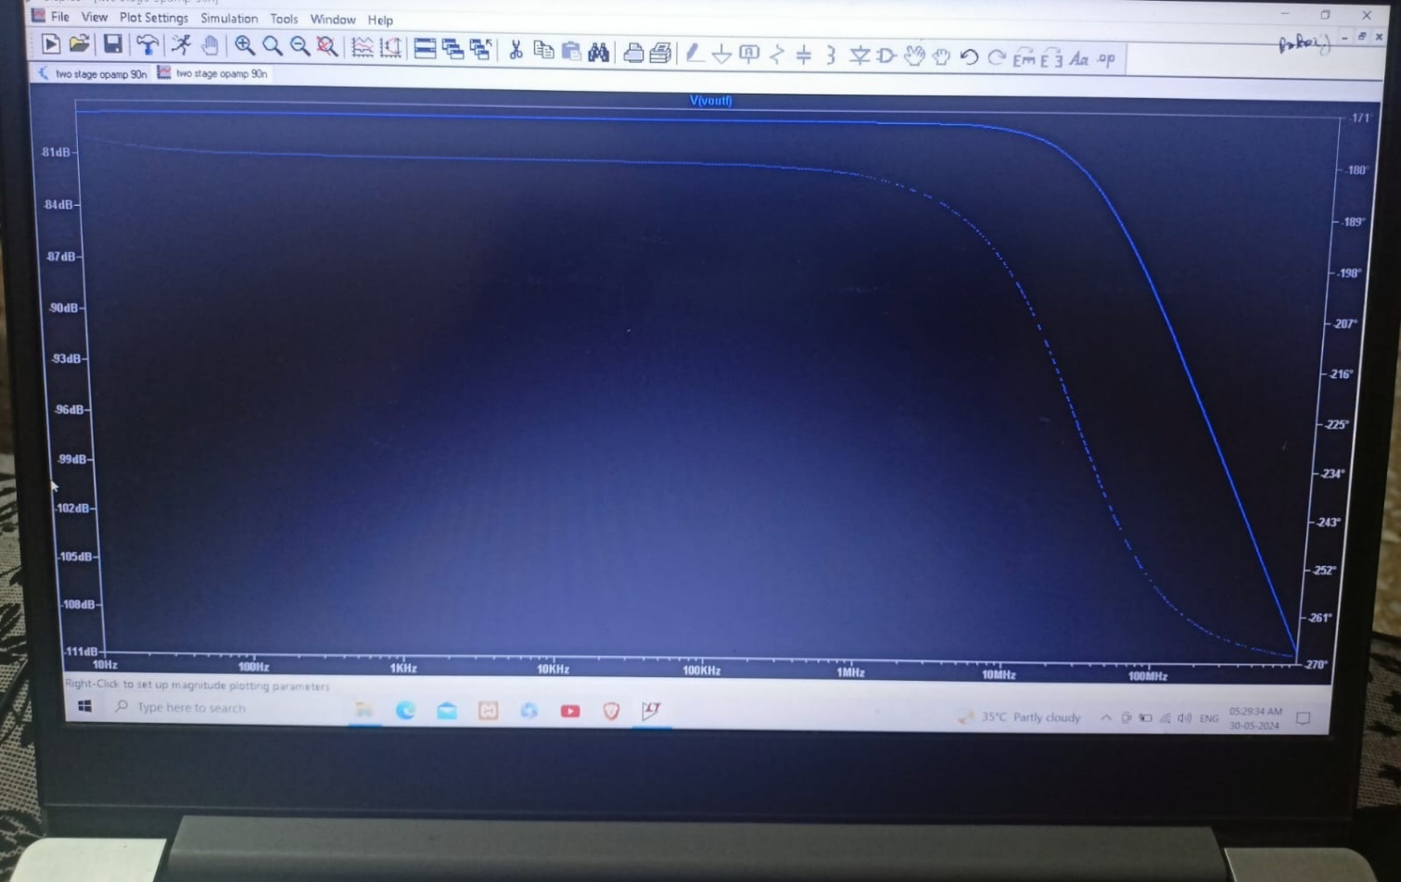

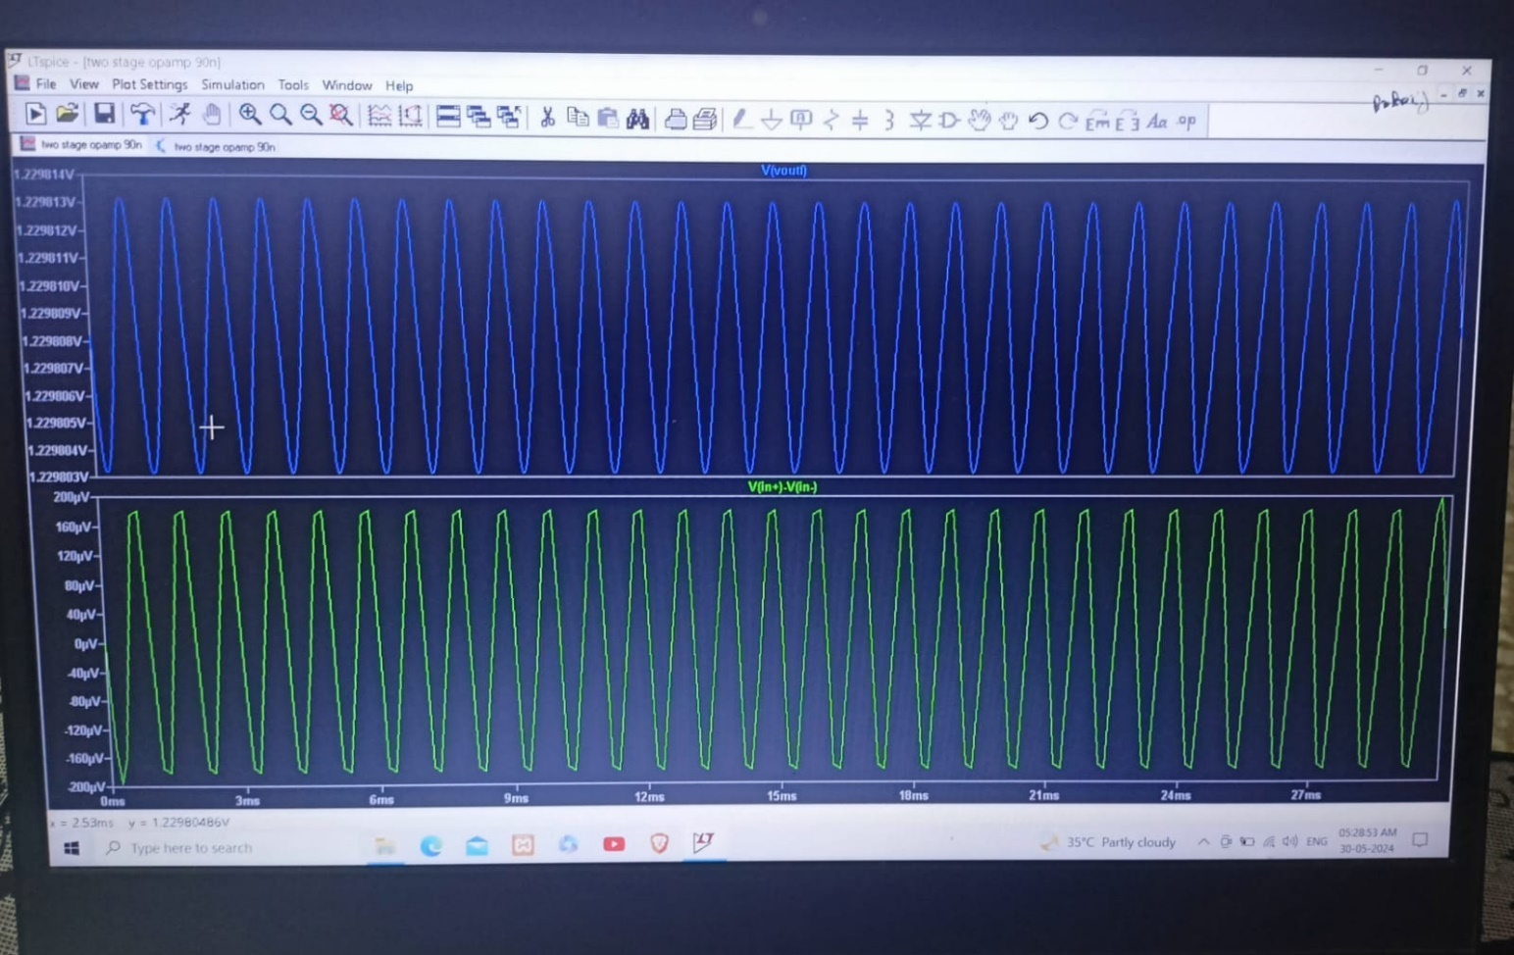

**CHAPTER 7**

**CONCLUSIONS**

The two-stage operational amplifier (OPAMP) project provided a detailed examination of the design and performance differences between 180nm and 90nm technology nodes using LTspice. Through the simulation and analysis of these nodes, several important conclusions can be drawn regarding their suitability for various applications, performance characteristics, and design trade-offs.

#### **Summary of Findings:**

1. **Design and Architecture:**
   * The two-stage opamp design, with its differential pair input stage followed by a gain stage, is fundamental in analog circuit design. This architecture is commonly used due to its ability to provide high gain and good phase margin.
   * The primary distinction between the two technology nodes lies in the physical dimensions of the transistors, with the 90nm technology featuring significantly smaller transistor sizes compared to the 180nm technology.
2. **Performance Comparison:**
   * **180nm Technology:** The opamp designed in 180nm technology exhibited moderate performance metrics. It operates at higher supply voltages (typically around 1.8V) and has larger transistors, leading to greater robustness and reliability. However, this also results in higher power consumption and lower integration density. The 180nm opamp is well-suited for applications where cost and design complexity are critical considerations and where extreme miniaturization is not necessary.
   * **90nm Technology:** The opamp designed in 90nm technology demonstrated superior performance, including higher speed, lower power consumption, and greater integration density. The smaller transistor sizes allow for lower operating voltages (typically around 1.2V), resulting in reduced power dissipation and improved efficiency. The 90nm opamp is ideal for high-performance applications such as mobile devices, high-speed computing, and advanced consumer electronics where space and power efficiency are paramount.
3. **Simulation and Analysis Results:**
   * **DC Analysis:** Both technology nodes achieved stable operating points with appropriate biasing. However, the 90nm opamp showed better efficiency due to lower voltage requirements.
   * **AC Analysis:** The frequency response analysis revealed that the 90nm OPAMP had a significantly wider bandwidth and improved high-frequency performance compared to the 180nm counterpart. This is critical for applications requiring fast signal processing and high-speed communication.
   * **Transient Analysis:** The time-domain simulations highlighted the faster response times and better transient performance of the 90nm opamp. It exhibited quicker rise and fall times and stabilized faster after transient events, which is beneficial for applications demanding rapid signal transitions and minimal delay.
4. **Impact of Technology Scaling:**
   * The transition from 180nm to 90nm technology nodes demonstrated significant advancements in semiconductor fabrication. The scaling down of transistors resulted in enhanced performance characteristics, including increased speed, reduced power consumption, and higher integration density. These improvements come with increased design complexity and higher manufacturing costs, necessitating more sophisticated design techniques and considerations.
   * Despite the higher complexity and costs, the benefits of 90nm technology make it highly desirable for modern high-performance applications where efficiency, speed, and miniaturization are crucial.

#### **Conclusion:**

The comparative analysis of the two-stage opamp using 180nm and 90nm technologies highlights the substantial benefits of technology scaling in semiconductor design. The 90nm technology node offers marked improvements in speed, power efficiency, and overall performance, making it the preferred choice for high-demand applications. Conversely, the 180nm technology remains relevant for cost-sensitive and less performance-critical applications where its robustness and lower design complexity are advantageous.

In conclusion, the choice between 180nm and 90nm technologies should be guided by the specific requirements of the application, balancing performance, power consumption, cost, and design complexity. This project underscores the importance of selecting the appropriate technology node to optimize the design and functionality of integrated circuits.